ASSINGMENT – 3.3
NAME : BERELLI PRIYANKA
HALL TICKET NO : 2303A52468
BATCH NO: 42
Task 1: AI-Generated Logic for Reading Consumer Details
Prompt : Generate a simple Python program to read PU, CU, and customer type, then calculate and display units consumed (CU − PU) without using functions.
CODE:
Generate a simple Python program to read PU, CU, and customer type, then calculate and display units consumed (CU − PU) without using functions.
```python# Read previous units (PU), current units (CU), and customer type
PU = float(input("Enter previous units (PU): "))
CU = float(input("Enter current units (CU): "))
customer_type = input("Enter customer type (residential/commercial): ").lower()
# Calculate units consumedunits_consumed = CU - PU
# Display the result
print(f"Units consumed: {units_consumed}")

OUTPUT :
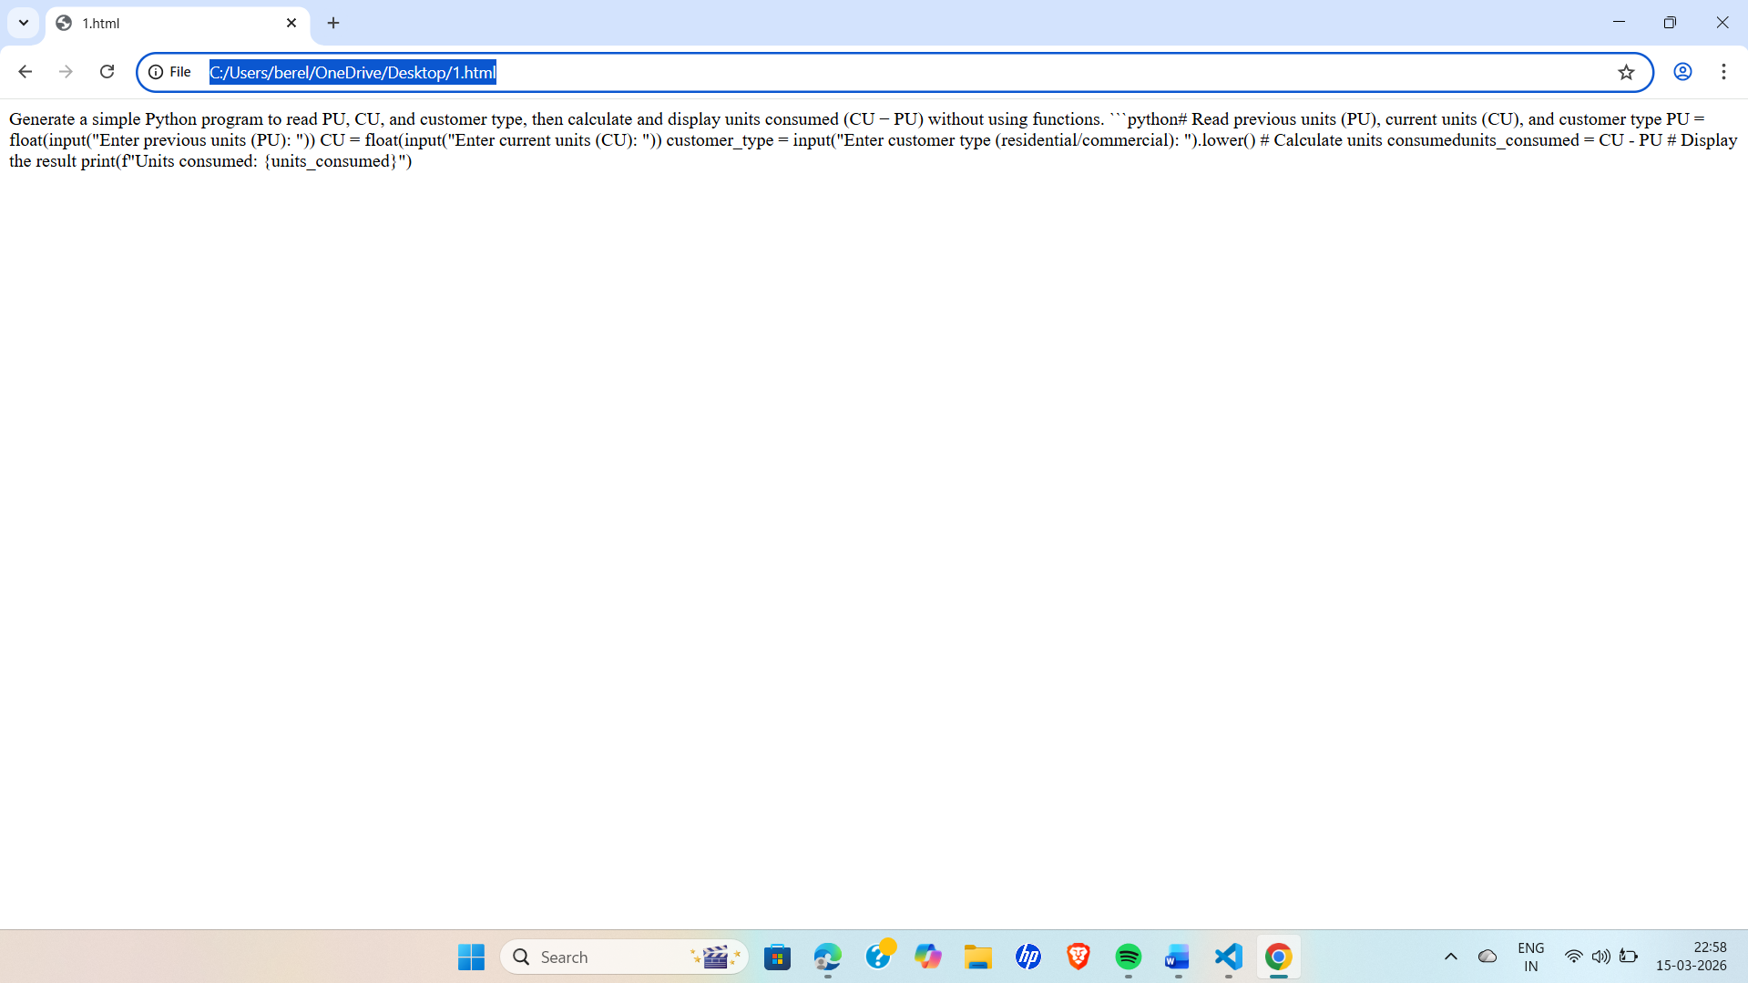
LINK : file:///C:/Users/berel/OneDrive/Desktop/1.html
EXPLAINATION : This task requires using an AI tool like GitHub Copilot or Google Gemini to generate a simple Python program that reads consumer details (PU, CU, customer type) and calculates the units consumed directly in the main program without using functions.

Task 2: Energy Charges Calculation Based on Units Consumed
Prompt : Generate a Python program to calculate energy charges based on units consumed and customer type using simple if-elif-else conditions.
CODE :
Generate a Python program to calculate energy charges based on units consumed and customer type using simple if-elif-else conditions.
```python# Read previous units (PU), current units (CU), and customer type
PU = float(input("Enter previous units (PU): "))
CU = float(input("Enter current units (CU): "))
customer_type = input("Enter customer type (residential/commercial): ").lower()
# Calculate units consumed
units_consumed = CU - PU
# Calculate charges based on customer type and units consumed
if customer_type == "residential":
if units_consumed <= 100:
charges = units_consumed * 0.5
elif units_consumed <= 200:
charges = 100 * 0.5 + (units_consumed - 100) * 0.75
else:
charges = 100 * 0.5 + 100 * 0.75 + (units_consumed - 200) * 1.0
elif customer_type == "commercial":
if units_consumed <= 100:
charges = units_consumed * 0.75
elif units_consumed <= 200:
charges = 100 * 0.75 + (units_consumed - 100) * 1.0
else:
charges = 100 * 0.75 + 100 * 1.0 + (units_consumed - 200) * 1.25
else:
print("Invalid customer type.")
charges = None
# Display the result
if charges is not None:
print(f"Units consumed: {units_consumed}")
print(f"Total charges: ${charges:.2f}")

OUTPUT :
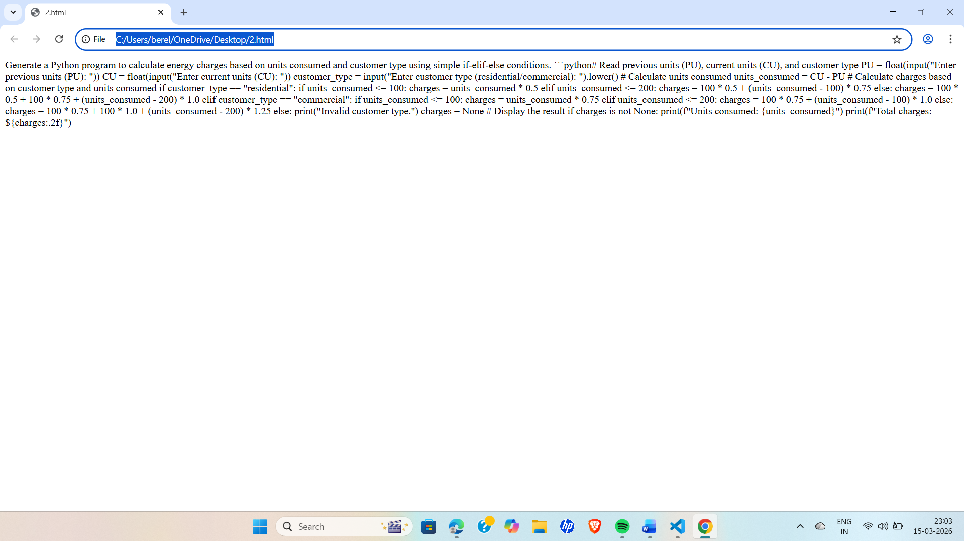

LINK : file:///C:/Users/berel/OneDrive/Desktop/2.html
EXPLAINATION : This task extends the electricity billing program by adding logic to calculate energy charges based on units consumed and customer type (Domestic, Commercial, Industrial) using conditional statements. The goal is to make the code clearer and more efficient with the help of AI tools like GitHub Copilot or Google Gemini.

Task 3: Modular Design Using AI Assistance (Using Functions)
Prompt : Generate a Python program using functions to calculate Energy Charges (EC) and Fixed Charges (FC) with comments and sample input/output.
CODE :
Generate a Python program using functions to calculate Energy Charges (EC) and Fixed Charges (FC) with comments and sample input/output.
```python# Function to calculate energy charges based on units consumed and customer type
def calculate_energy_charges(un
its_consumed, customer_type):
if customer_type == "residential":
if units_consumed <= 100:
return units_consumed * 0.5
elif units_consumed <= 200:
return 100 * 0.5 + (units_consumed - 100) * 0.75
else:
return 100 * 0.5 + 100 * 0.75 + (units_consumed - 200) * 1.0
elif customer_type == "commercial":
if units_consumed <= 100:
return units_consumed * 0.75
elif units_consumed <= 200:
return 100 * 0.75 + (units_consumed - 100) * 1.0
else:
return 100 * 0.75 + 100 * 1.0 + (units_consumed - 200) * 1.25
else:
print("Invalid customer type.")
return None
# Function to calculate fixed charges based on customer type
def calculate_fixed_charges(customer_type):
if customer_type == "residential":
return 50
elif customer_type == "commercial":
return 100
else:
print("Invalid customer type.")
return None
# Main program
def main():
# Read previous units (PU), current units (CU), and customer type
PU = float(input("Enter previous units (PU): "))
CU = float(input("Enter current units (CU): "))
customer_type = input("Enter customer type (residential/commercial): ").lower()
# Calculate units consumed
units_consumed = CU - PU
# Calculate energy charges and fixed charges
energy_charges = calculate_energy_charges(units_consumed, customer_type)
fixed_charges = calculate_fixed_charges(customer_type)
# Display the results
if energy_charges is not None and fixed_charges is not None:
print(f"Units consumed: {units_consumed}")
print(f"Energy Charges: ${energy_charges:.2f}")
print(f"Fixed Charges: ${fixed_charges:.2f}")
if __name__ == "__main__":
main()
# Sample Input/Output
# Enter previous units (PU): 150
# Enter current units (CU): 250
# Enter customer type (residential/commercial): residential
# Units consumed: 100.0
# Energy Charges: $75.00
# Fixed Charges: $50.00
```

OUTPUT :
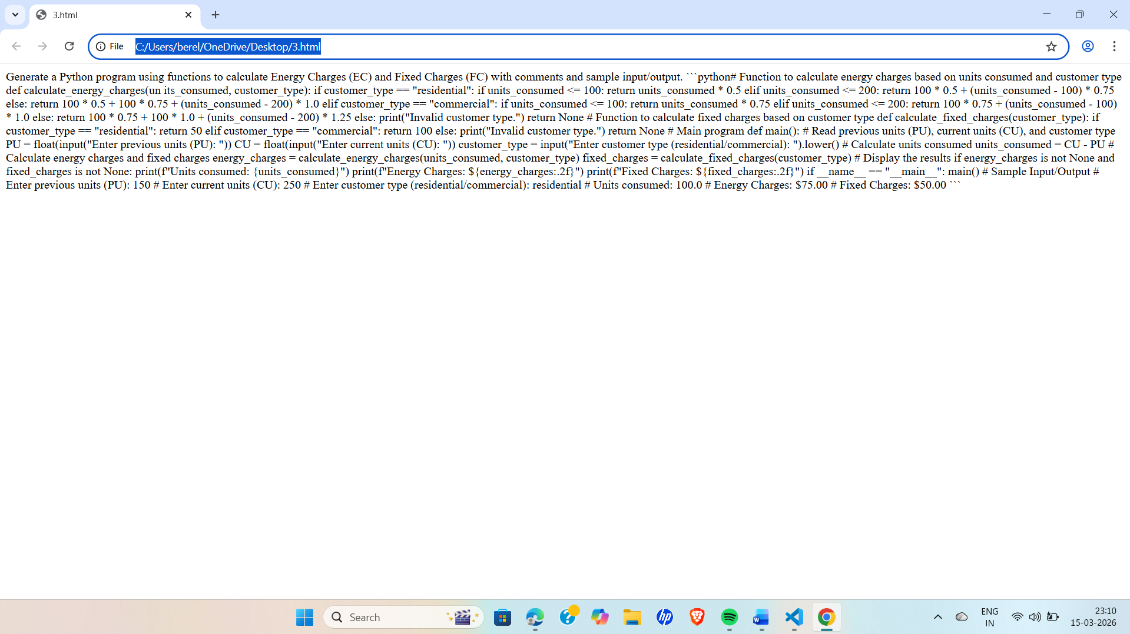

LINK : file:///C:/Users/berel/OneDrive/Desktop/3.html

EXPLAINATION : This task focuses on improving the electricity billing program by using user-defined functions to calculate Energy Charges (EC) and Fixed Charges (FC). The goal is to make the code modular, reusable, and easier to maintain, with help from AI tools like GitHub Copilot or Google Gemini.

Task 4: Calculation of Additional Charges
Prompt : Generate a Python program that calculates Fixed Charges (FC), Customer Charges (CC), and Electricity Duty (ED as a percentage of EC) and displays all charges clearly with sample input/output.
CODE:
Generate a Python program that calculates Fixed Charges (FC), Customer Charges (CC), and Electricity Duty (ED as a percentage of EC) and displays all charges clearly with sample input/output.
```python# Function to calculate energy charges based on units consumed and customer type
def calculate_energy_charges(units_consumed, customer_type):
if customer_type == "residential":
if units_consumed <= 100:
return units_consumed * 0.5
elif units_consumed <= 200:
return 100 * 0.5 + (units_consumed - 100) * 0.75
else:
return 100 * 0.5 + 100 * 0.75 + (units_consumed - 200) * 1.0
elif customer_type == "commercial":
if units_consumed <= 100:
return units_consumed * 0.75
elif units_consumed <= 200:
return 100 * 0.75 + (units_consumed - 100) * 1.0
else:
return 100 * 0.75 + 100 * 1.0 + (units_consumed - 200) * 1.25
else:
print("Invalid customer type.")
return None
# Function to calculate fixed charges based on customer type
def calculate_fixed_charges(customer_type):
if customer_type == "residential":
return 50
elif customer_type == "commercial":
return 100
else:
print("Invalid customer type.")
return None
# Function to calculate electricity duty as a percentage of energy charges
def calculate_electricity_duty(energy_charges):
return energy_charges * 0.05 # Assuming electricity duty is 5% of energy charges
# Main program
def main():
# Read previous units (PU), current units (CU), and customer type
PU = float(input("Enter previous units (PU): "))
CU = float(input("Enter current units (CU): "))
customer_type = input("Enter customer type (residential/commercial): ").lower()
# Calculate units consumed
units_consumed = CU - PU
# Calculate energy charges, fixed charges, and electricity duty
energy_charges = calculate_energy_charges(units_consumed, customer_type)
fixed_charges = calculate_fixed_charges(customer_type)
electricity_duty = calculate_electricity_duty(energy_charges) if energy_charges is not None else None
# Display the results
if energy_charges is not None and fixed_charges is not None and electricity_duty is not None:
print(f"Units consumed: {units_consumed}")
print(f"Energy Charges: ${energy_charges:.2f}")
print(f"Fixed Charges: ${fixed_charges:.2f}")
print(f"Electricity Duty: ${electricity_duty:.2f}")
if __name__ == "__main__":
main()
# Sample Input/Output
# Enter previous units (PU): 150
# Enter current units (CU): 250
# Enter customer type (residential/commercial): residential
# Units consumed: 100.0
# Energy Charges: $75.00
# Fixed Charges: $50.00
# Electricity Duty: $3.75

OUTPUT :
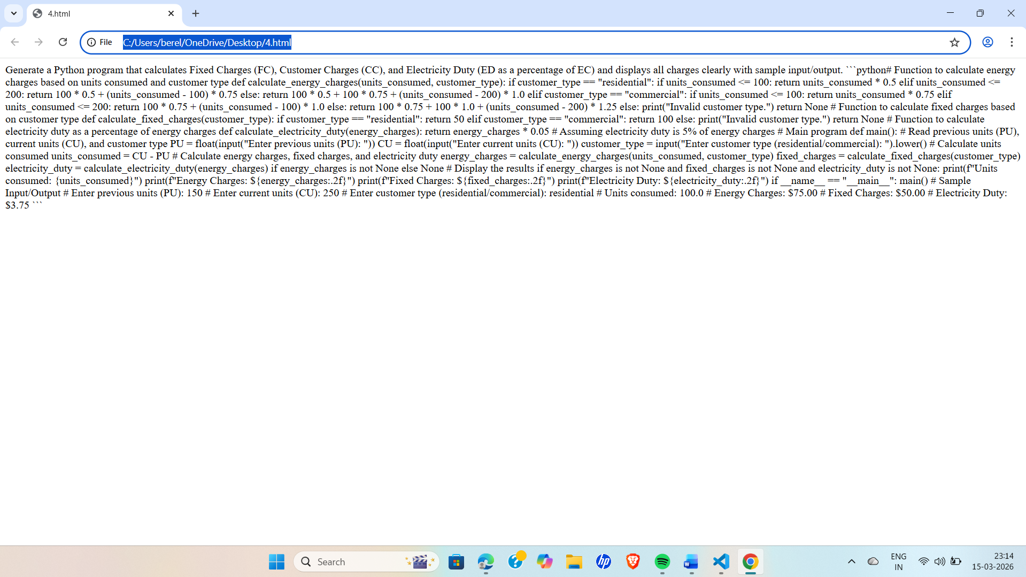

LINK : file:///C:/Users/berel/OneDrive/Desktop/4.html

EXPLAINATION : This task extends the electricity billing program by adding additional charges like Fixed Charges (FC), Customer Charges (CC), and Electricity Duty (ED). The program should calculate each charge correctly (ED as a percentage of EC) and display them clearly using help from AI tools like GitHub Copilot or Google Gemini.

Task 5: Final Bill Generation and Output Analysis
Prompt : Generate a Python program that calculates the total electricity bill (EC + FC + CC + ED) and displays all charges clearly with formatted output and sample input/output.

CODE :
Generate a Python program that calculates the total electricity bill (EC + FC + CC + ED) and displays all charges clearly with formatted output and sample input/output.
```python# Function to calculate energy charges based on units consumed and customer type
def calculate_energy_charges(units_consumed, customer_type):
if customer_type == "residential":
if units_consumed <= 100:
return units_consumed * 0.5
elif units_consumed <= 200:
return 100 * 0.5 + (units_consumed - 100) * 0.75
else:
return 100 * 0.5 + 100 * 0.75 + (units_consumed - 200) * 1.0
elif customer_type == "commercial":
if units_consumed <= 100:
return units_consumed * 0.75
elif units_consumed <= 200:
return 100 * 0.75 + (units_consumed - 100) * 1.0
else:
return 100 * 0.75 + 100 * 1.0 + (units_consumed - 200) * 1.25
else:
print("Invalid customer type.")
return None
# Function to calculate fixed charges based on customer type
def calculate_fixed_charges(customer_type):
if customer_type == "residential":
return 50
elif customer_type == "commercial":
return 100
else:
print("Invalid customer type.")
return None
# Function to calculate customer charges based on customer type
def calculate_customer_charges(customer_type):
if customer_type == "residential":
return 20
elif customer_type == "commercial":
return 40
else:
print("Invalid customer type.")
return None
# Function to calculate electricity duty as a percentage of energy charges
def calculate_electricity_duty(energy_charges):
return energy_charges * 0.05 # Assuming electricity duty is 5% of energy charges
# Main program
def main():
# Read previous units (PU), current units (CU), and customer type
PU = float(input("Enter previous units (PU): "))
CU = float(input("Enter current units (CU): "))
customer_type = input("Enter customer type (residential/commercial): ").lower()
# Calculate units consumed
units_consumed = CU - PU
# Calculate energy charges, fixed charges, customer charges, and electricity duty
energy_charges = calculate_energy_charges(units_consumed, customer_type)
fixed_charges = calculate_fixed_charges(customer_type)
customer_charges = calculate_customer_charges(customer_type)
electricity_duty = calculate_electricity_duty(energy_charges) if energy_charges is not None else None
# Calculate total bill
total_bill = energy_charges + fixed_charges + customer_charges + electricity_duty if None not in (energy_charges, fixed_charges, customer_charges, electricity_duty) else None
# Display the results
if total_bill is not None:
print(f"Units consumed: {units_consumed}")
print(f"Energy Charges: ${energy_charges:.2f}")
print(f"Fixed Charges: ${fixed_charges:.2f}")
print(f"Customer Charges: ${customer_charges:.2f}")
print(f"Electricity Duty: ${electricity_duty:.2f}")
print(f"Total Bill: ${total_bill:.2f}")
if __name__ == "__main__":
main()
# Sample Input/Output
# Enter previous units (PU): 150
# Enter current units (CU): 250
# Enter customer type (residential/commercial): residential
# Units consumed: 100.0
# Energy Charges: $75.00
# Fixed Charges: $50.00
# Customer Charges: $20.00
# Electricity Duty: $3.75
# Total Bill: $148.75
```

OUTPUT :
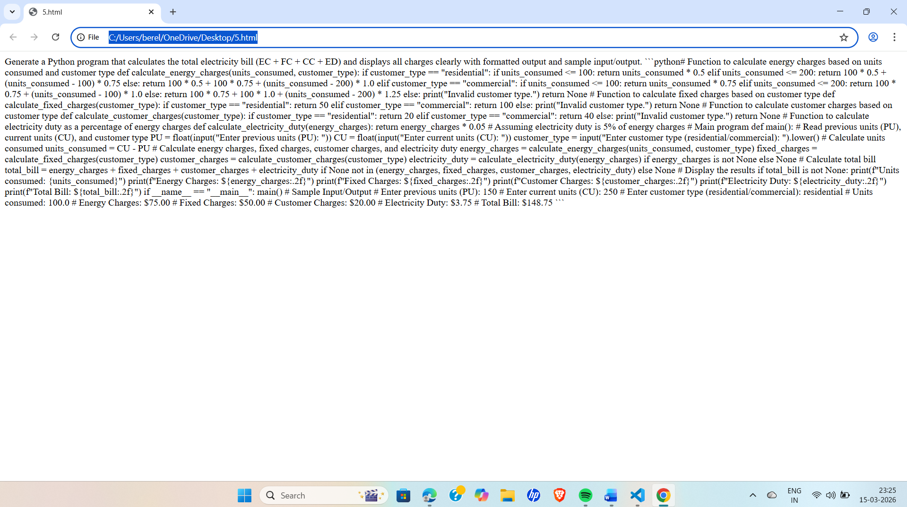
LINK : file:///C:/Users/berel/OneDrive/Desktop/5.html

EXPLAINATION : This task focuses on creating the final electricity billing program that calculates the total bill (EC + FC + CC + ED) and displays each charge clearly. It also requires analyzing the program based on accuracy, readability, and real-world usefulness, using help from AI tools like GitHub Copilot or Google Gemini.

